**NAME: SOFIA AAMIR**

**REGISTRATION NO: FA21-BSE-036**

**OOSE MID LAB**

**PROCESS CONSUMPTION (ELECTRICITY METER):**

* **MAIN SUCCESS SCENERIO:**
* Main Success Scenario: Consumption Process

| **Step** | **User Interaction** | **System Response** |
| --- | --- | --- |
| 1 | The system collects electricity consumption data from various sources, including smart meters and other sources. | The system retrieves and stores the electricity consumption data in its database. |
| 2 | The system preprocesses the collected data to remove errors or inconsistencies, such as validating the data, handling missing values, and normalizing the consumption values. | The system applies preprocessing techniques to clean and prepare the data for analysis. |
| 3 | The system analyzes the consumption patterns of each customer to establish a baseline or expected consumption profile. This involves considering factors like historical consumption data, weather conditions, and customer characteristics. | The system performs pattern analysis to create a consumption profile for each customer. |
| 4 | The system compares the actual consumption of each customer with his or her expected consumption profile. If an inconsistency is detected, the system generates an alarm. | The system identifies any deviations or anomalies in the consumption patterns and triggers an alarm. |
| 5 | The alarm is sent to the utility company or relevant authorities, providing details such as the customer's identity, nature of the anomaly, and severity of potential theft. | The system generates and sends an alarm notification to the utility company or authorities with the relevant information. |
| 6 | The utility company initiates an investigation into the flagged customer's account. This may involve further analysis, on-site inspections, or collaboration with law enforcement agencies to verify the presence of electricity theft. | The utility company reviews the alarm and starts an investigation process to verify the suspected electricity theft. |
| 7 | If the investigation confirms the occurrence of electricity theft, appropriate actions are taken, such as disconnecting illegal connections, imposing penalties, initiating legal proceedings, or recovering stolen electricity charges. | The utility company takes necessary actions based on the investigation results, which may include disconnection, penalties, legal actions, or recovery of stolen charges. |
| 8 | The system continues to monitor consumption patterns to detect and prevent future instances of electricity theft. It adapts and updates the baseline consumption profiles based on changing customer behavior, seasons, or other relevant factors. | The system continuously monitors consumption patterns, updates the baseline profiles, and implements preventive measures to minimize electricity theft. |

* **SYSTEM SEQUENCE DIAGRAM OF PROCESS CONSUMPTION:**

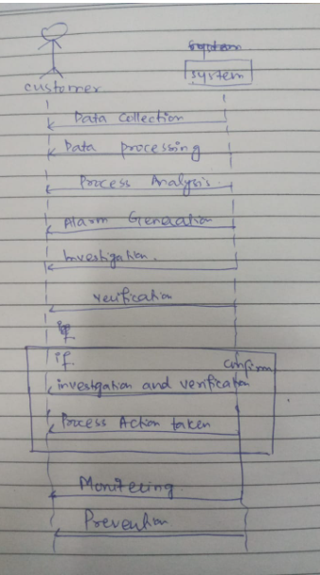

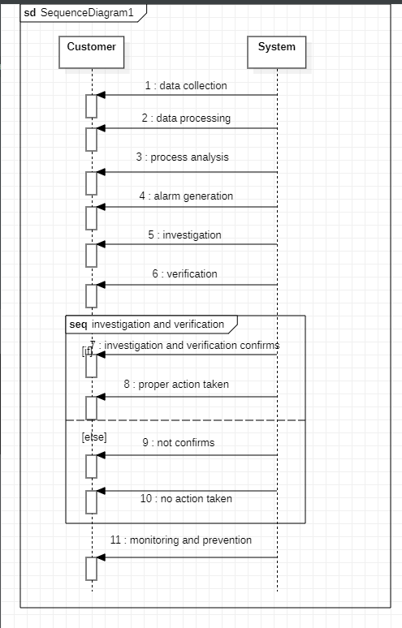

* **PROTOTYPES:**
* **MAIN PAGE:**

This is the main page in which I have taken only few functionalities. My use case is Process Consumption. If the electricity meter handler will click on process consumption button the handler will go then to Process consumption page.

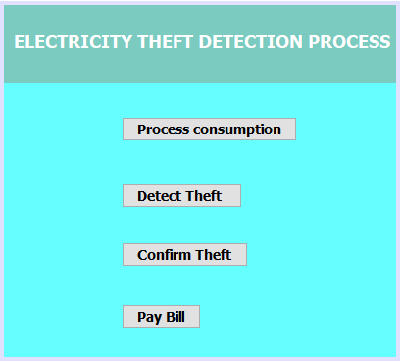

* **PROCESS CONSUMPTION PROCESS:**

After clicking on process consumption button the handler will move to anither page. There is the name of customer and cnic of customer. That will be enter by the handler and the handler will also choose that through which process the customer has steal the power. And then the handler will confirm that by clicking on confirm button.

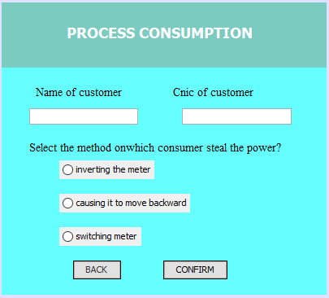

* **GENERATE ALARM PAGE:**

After clicking on confirm button on process consumption page the handler will then generate alarm for the customer.

